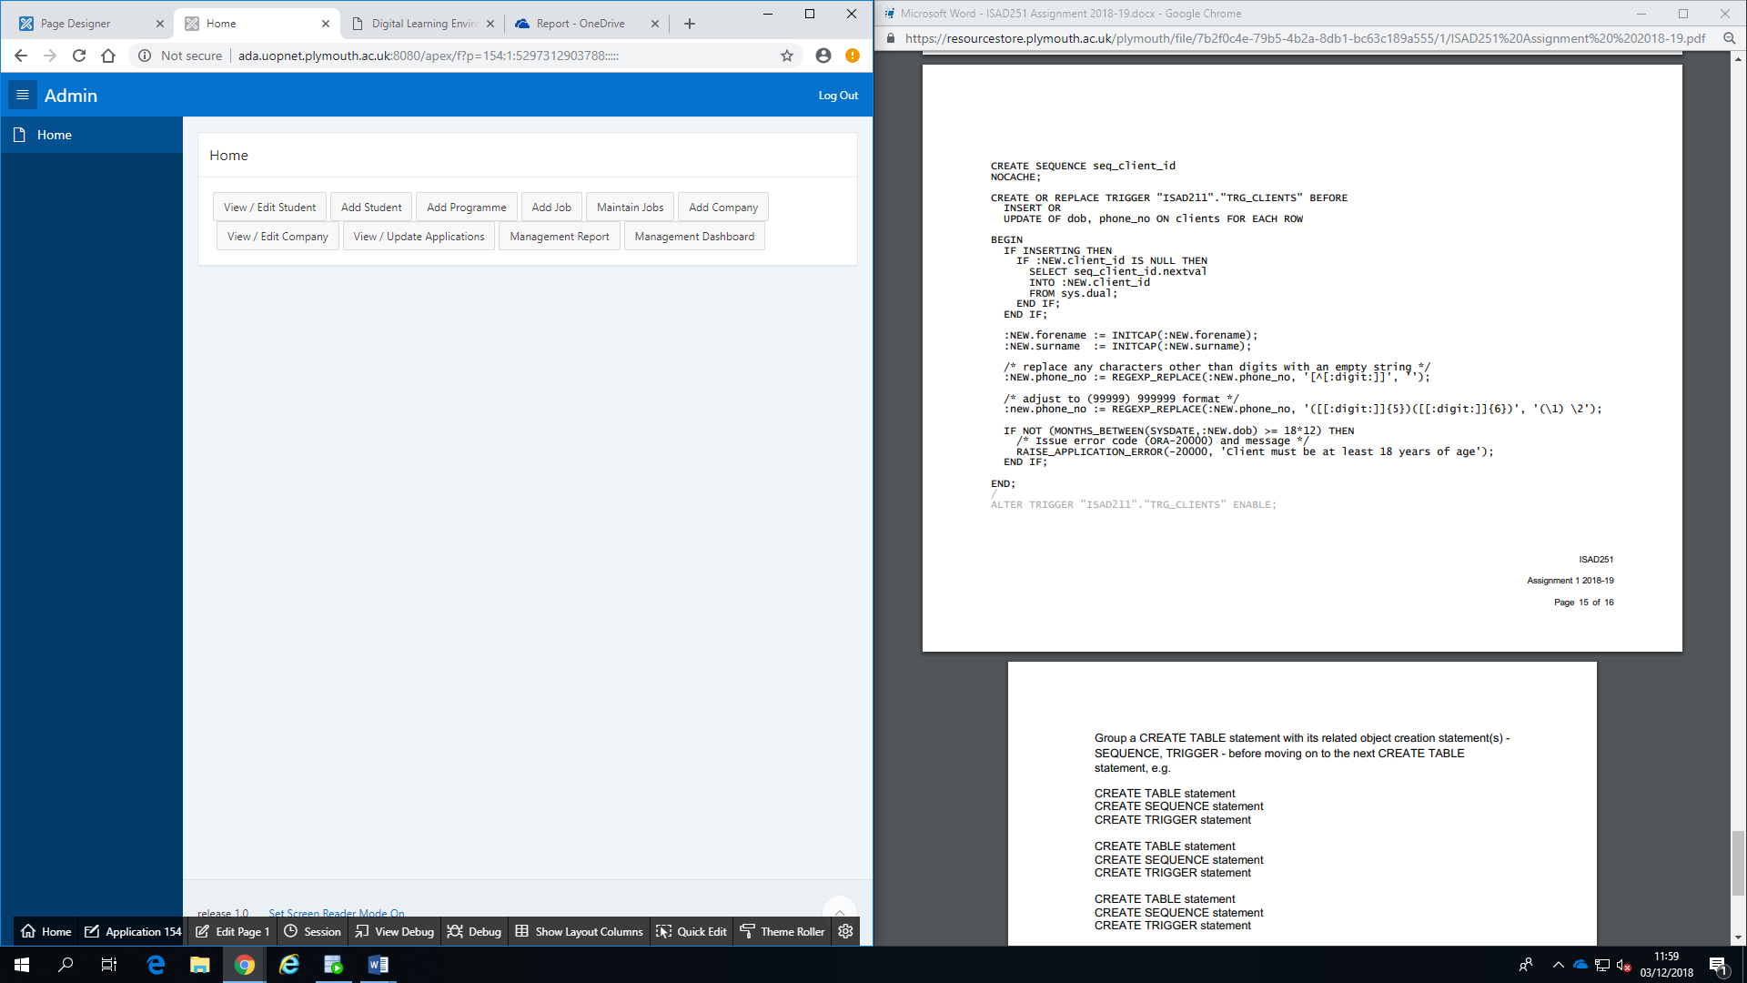1 – Home Page

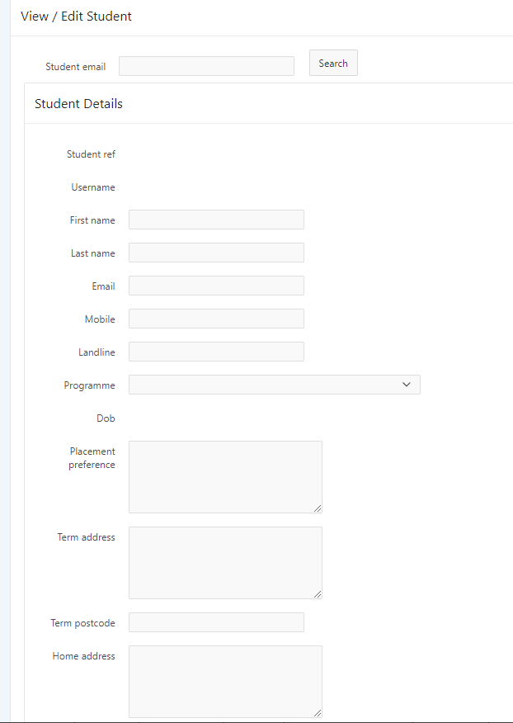2 – View/Edit Student

Specific pieces of data, such as student reference number and Date of Birth, are uneditable. This is to provide client side data integrity of vital information. When clicking the Accept CV Button, the current date is added as the CV accepted date if there is a CV submitted date.

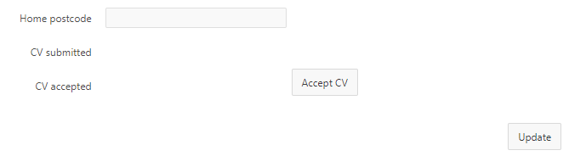

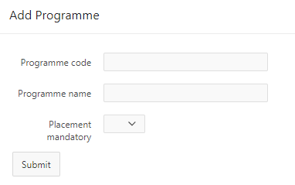3 – Add Programmes

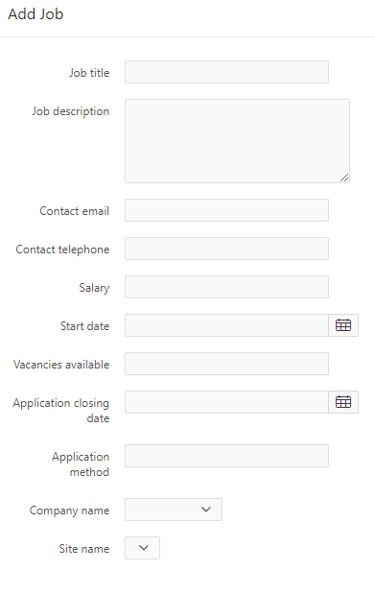4 – Add Job

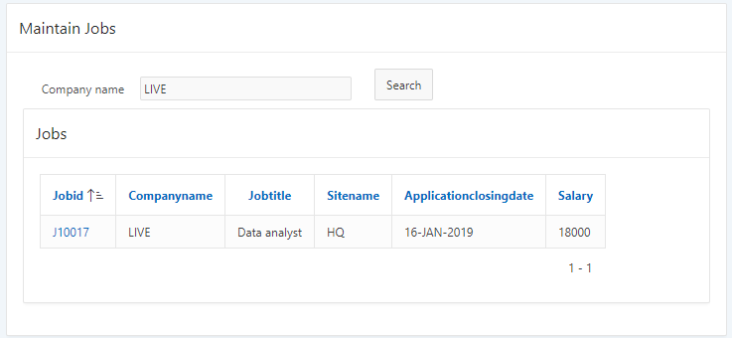5 – Manage Jobs

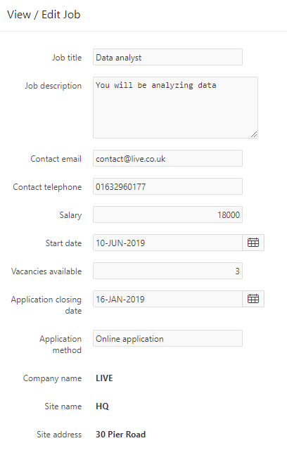

Clicking on a job ID will take the user to another page where they are able to manage the jobs details.

6 – View/Edit Company

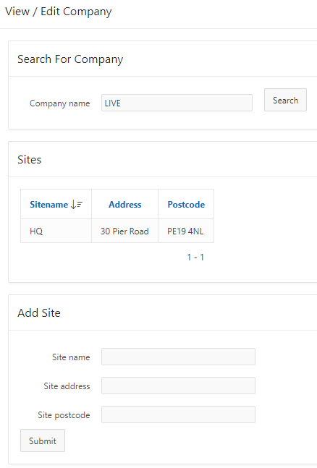To add a site, the user must first search for a company. The company searched for is then added to the site as a foreign key.

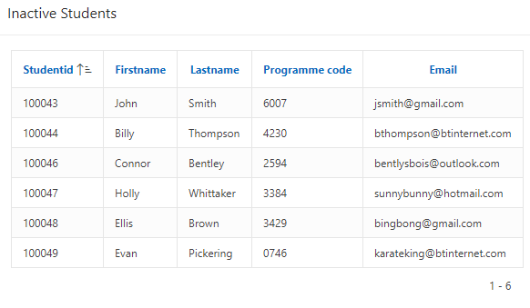8.2 – Management Reports: Inactive Students

9 – Job Vacancy Calendar

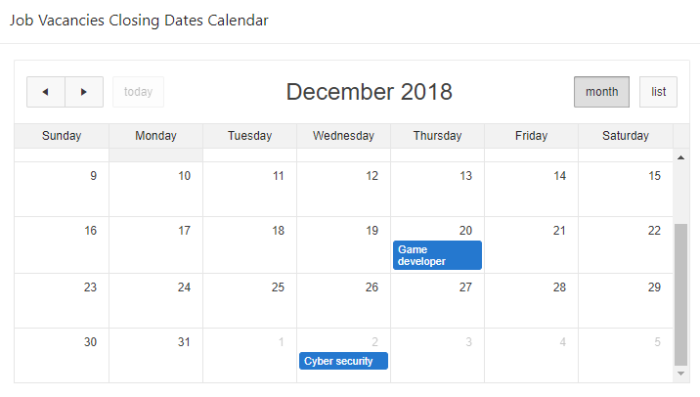10 – Pie Chart

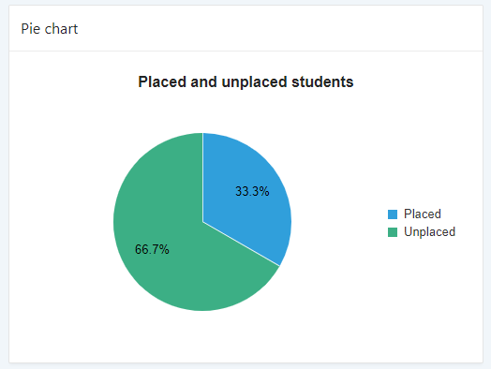

8.1 - Management Reports: Active Students

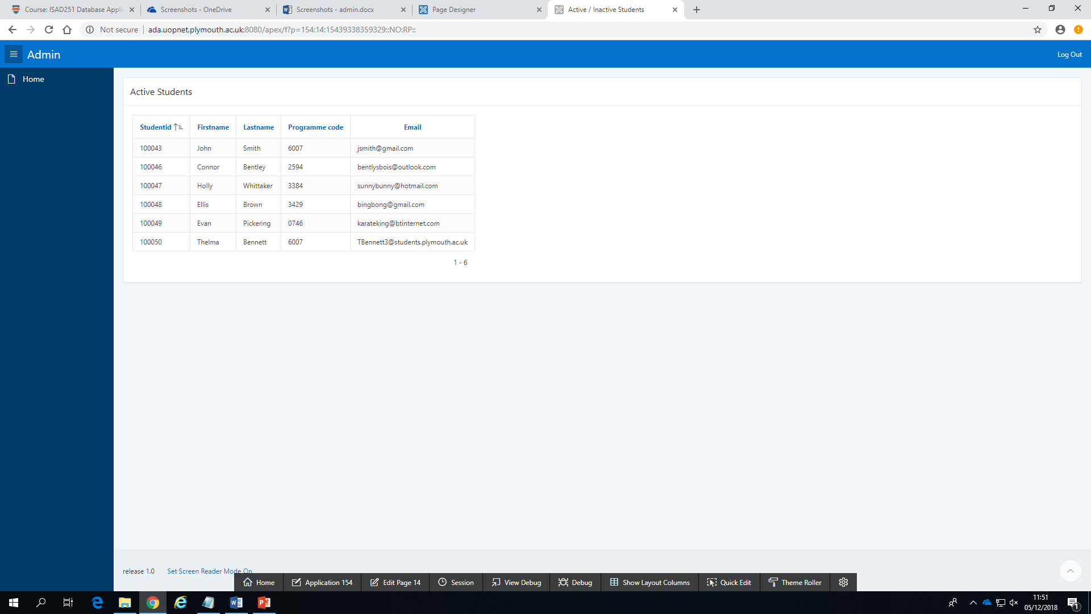

8.3 - Management Reports: Placed Students

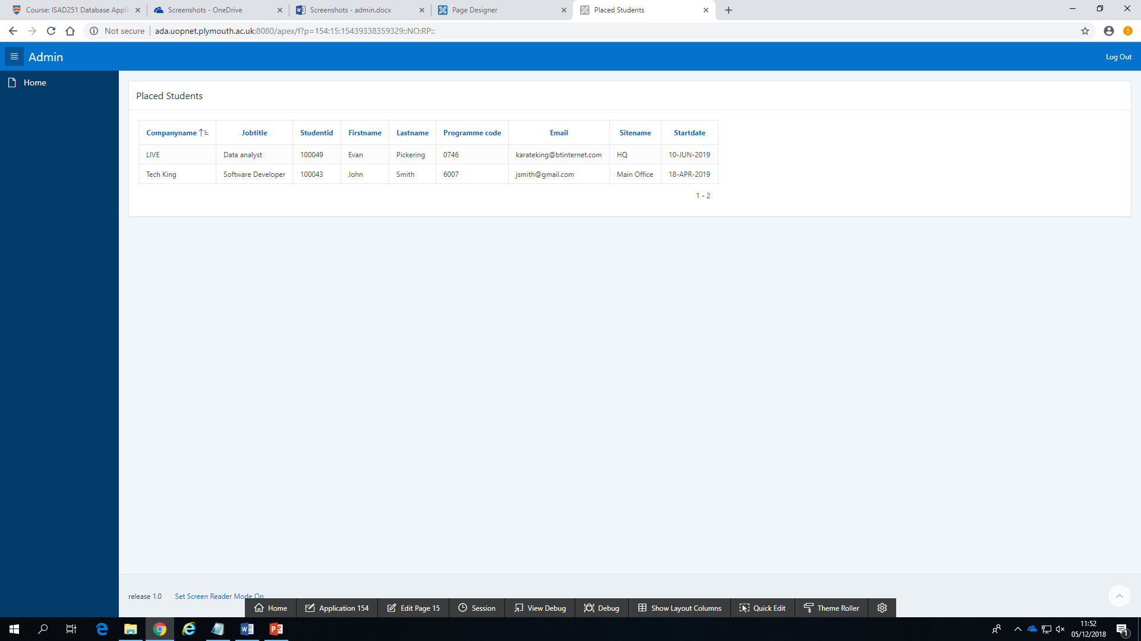

8.4 - Management Reports: Active Students Not Placed

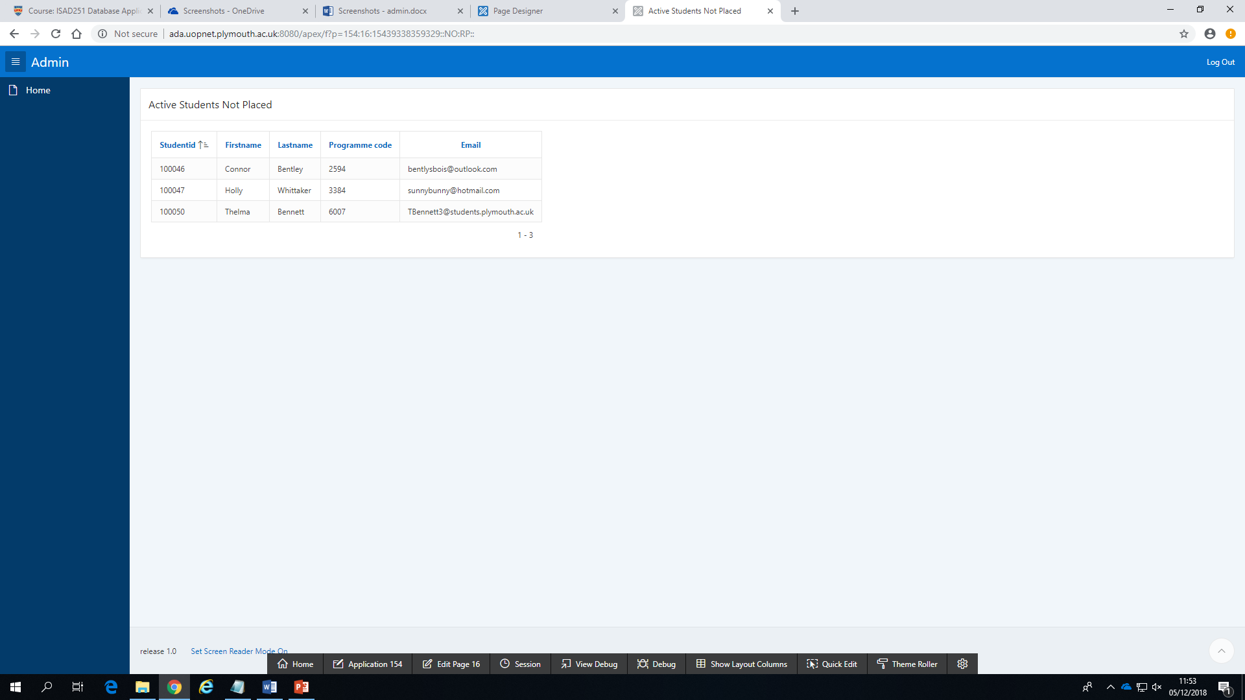

8.5 - Management Reports: Closing Vacancies

